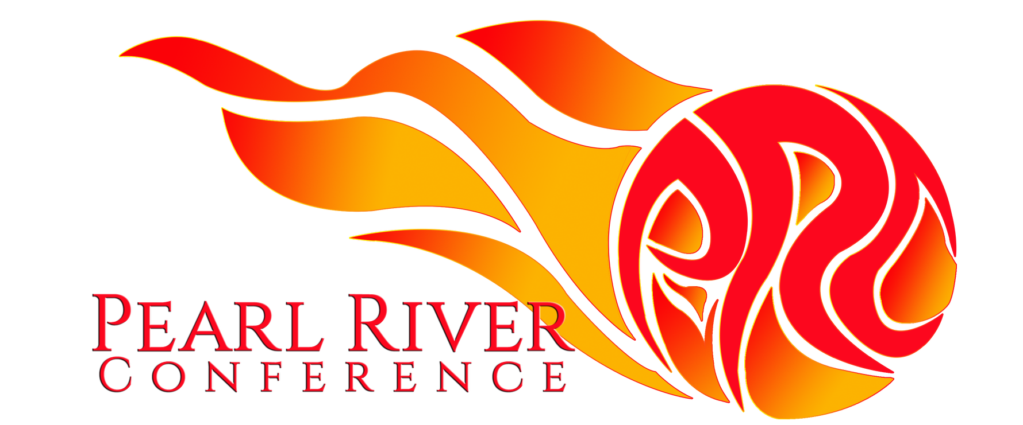
COVID-19 Safety Protocol Baseline
Purpose: This document is meant to act as a minimum baseline that all Pearl River Conference schools will abide by when hosting or attending any PRC event. Host schools can add additional school or venue-specific protocols and procedures. Host schools are required to share any additional safety protocols or procedures for attending the event at least 14 days in advance understanding that the situation is fluid and can change anytime.
At minimum, any PRC event should follow the below protocols:
- Temperature & COVID symptoms checked before schools leave for event, rechecked on entry to venue. Any visitor with a temperature of above 37.3ºC is considered to have a fever and should not board the bus or enter the venue. If one player presents with fever, the entire team will not be permitted to enter the venue.
- Health QR Codes must be shown green on arrival to a host school security, nurse or school administrator. If a player does not have a phone, the parent must send a screenshot of their green Health QR Code on the morning of the event for the coach to provide upon arrival. Any visitor who is unable to show a green Health QR Code should not enter the venue. If one player presents without a green Health QR Code, the entire team will not be permitted to enter the venue.
- The host school should assure there is a process and capacity to identify and isolate any suspected cases in order to be compliant with local authorities and share that process with attending schools at least 14 days before the first day of the event.
- Nonessential visitors such as team managers, spectators, and parents are not permitted to attend unless notified otherwise.
*All schools understand that an attending school or event may cancel at any time.
*The above will be reviewed on a seasonal basis by the Executive Committee and any updates will be shared with all PRC Member School Athletic Directors.
*Athletic Directors should share the above for approval by their respective Head of School.

